### **Networks Fundamentals II Homework**

### **Mission 1**

**Issue**: Due to the DoS attack, the Empire took down the Resistance's DNS and primary email servers.

* The Resistance's network team was able to build and deploy a new DNS server and mail server.
* The new primary mail server is asltx.l.google.com and the secondary should be asltx.2.google.com.
* The Resistance (starwars.com) is able to send emails but is unable to receive any.

Your mission:

* Determine and document the mail servers for starwars.com using NSLOOKUP.

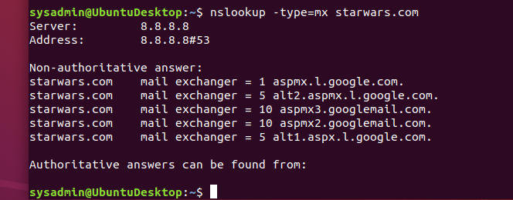

* Explain why the Resistance isn't receiving any emails. The resistance isn’t receiving because the two new server are not listed in the DNS list
* Document what a corrected DNS record should be. A corrected DNS record should have the lowest priority.

o starwars.com mail exchanger = 1 asltx.l.google.com

o starwars.com mail exchanger = 5 asltx.2.google.com

### 

### **Mission 2**

**Issue**: Now that you've addressed the mail servers, all emails are coming through. However, users are still reporting that they haven't received mail from the theforce.net alert bulletins.

* Many of the alert bulletins are being blocked or going into spam folders.
* This is probably due to the fact that theforce.net changed the IP address of their mail server to 45.23.176.21while your network was down.
* These alerts are critical to identify pending attacks from the Empire.

Your mission:

* Determine and document the SPF for theforce.net using NSLOOKUP.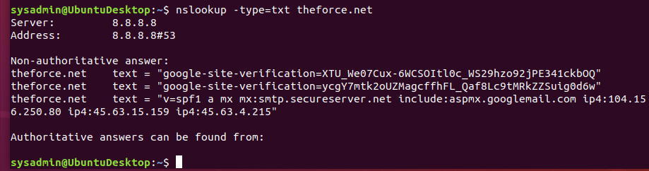
* Explain why the Force's emails are going to spam. The emails are going to spam because theforce.net changed their IP address of their mail server to 45.23
* Document what a corrected DNS record should be. theforce.net text = “v=spf1 a mx:smtp.secureserver.net include:aspmx.googlemail.com ip4:104.156.250.80 ip4:45.63.15.159 ip4:45.63.4.215 ip4:45.23.176.21”

### **Mission 3**

**Issue**: You have successfully resolved all email issues and the resistance can now receive alert bulletins. However, the Resistance is unable to easily read the details of alert bulletins online.

* They are supposed to be automatically redirected from their sub page of resistance.theforce.net to theforce.net.

Your mission:

* Document how a CNAME should look by viewing the CNAME of www.theforce.net using NSLOOKUP.

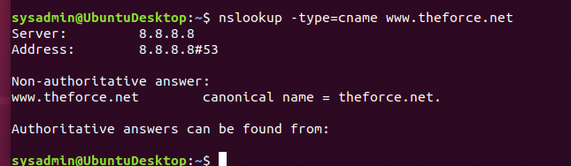

* Explain why the sub page of resistance.theforce.net isn't redirecting to theforce.net.Because the resistance.theforce.net does not have an alias with therefore.net
* Document what a corrected DNS record should be. Need to add the resistance.theforce.net as the cname for theforce.net

Non-authoritative answer:

www.theforce.net canonical name = theforce.net.

Resistance.theforce.net canonical name = theforce.net.

### **Mission 4**

**Issue**: During the attack, it was determined that the Empire also took down the primary DNS server of princessleia.site.

* Fortunately, the DNS server for princessleia.site is backed up and functioning.
* However, the Resistance was unable to access this important site during the attacks and now they need you to prevent this from happening again.
* The Resistance's networking team provided you with a backup DNS server of: ns2.galaxybackup.com.

Your mission:

* Confirm the DNS records for princessleia.site.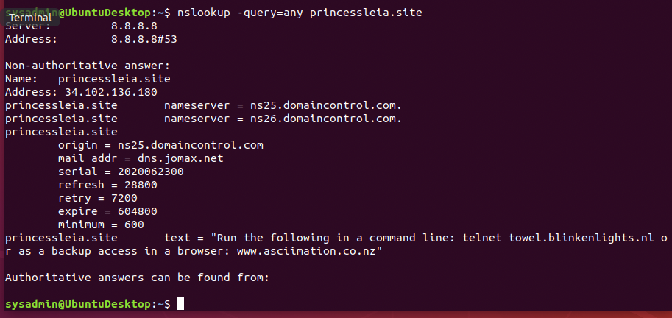
* Document how you would fix the DNS record to prevent this issue from happening again.

princessleia.site nameserver = ns25.domaincontrol.com.

princessleia.site nameserver = ns26.domaincontrol.com.

princessleia.site nameserver = ns2.galaxybackup.com.

### **Mission 5**

**Issue**: The network traffic from the planet of Batuu to the planet of Jedha is very slow.

* You have been provided a network map with a list of planets connected between Batuu and Jedha.
* It has been determined that the slowness is due to the Empire attacking Planet N.

Your Mission:

* View the Galaxy Network Map and determine the OSPF shortest path from Batuu to Jedha. The shortest part

Batuu > D (1) > C (2) > E (1) > F (1) > J (1) > I (1) > L (6) > Q (4) > T (2) > V (2) > Jedha (2) = 23 hops

* Confirm your path doesn't include Planet N in its route.

Batuu > D (1) > C (2) > E (1) > F (1) > J (1) > I (1) > L (6) > Q (4) > T (2) > V (2) > Jedha (2) = 23 hops

* Document this shortest path so it can be used by the Resistance to develop a static route to improve the traffic.

### **Mission 6**

**Issue:** Due to all these attacks, the Resistance is determined to seek revenge for the damage the Empire has caused.

* You are tasked with gathering secret information from the Dark Side network servers that can be used to launch network attacks against the Empire.
* You have captured some of the Dark Side's encrypted wireless internet traffic in the following pcap: Darkside.pcap.

Your Mission:

* Figure out the Dark Side's secret wireless key by using Aircrack-ng.
  + Hint: This is a more challenging encrypted wireless traffic using WPA.
  + In order to decrypt, you will need to use a wordlist (-w) such as rockyou.txt.
* Use the Dark Side's key to decrypt the wireless traffic in Wireshark.
  + Hint: The format for they key to decrypt wireless is <Wireless_key>:<SSID>.
* Once you have decrypted the traffic, figure out the following Dark Side information:
  + Host IP Addresses and MAC Addresses by looking at the decrypted ARP traffic.
  + Document these IP and MAC Addresses, as the resistance will use these IP addresses to launch a retaliatory attack.
  + 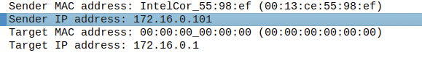

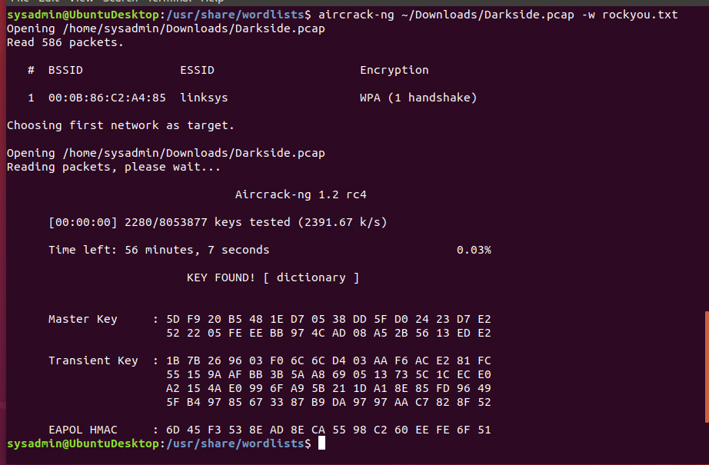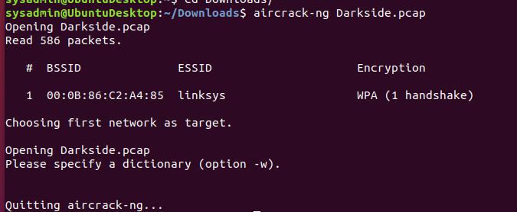

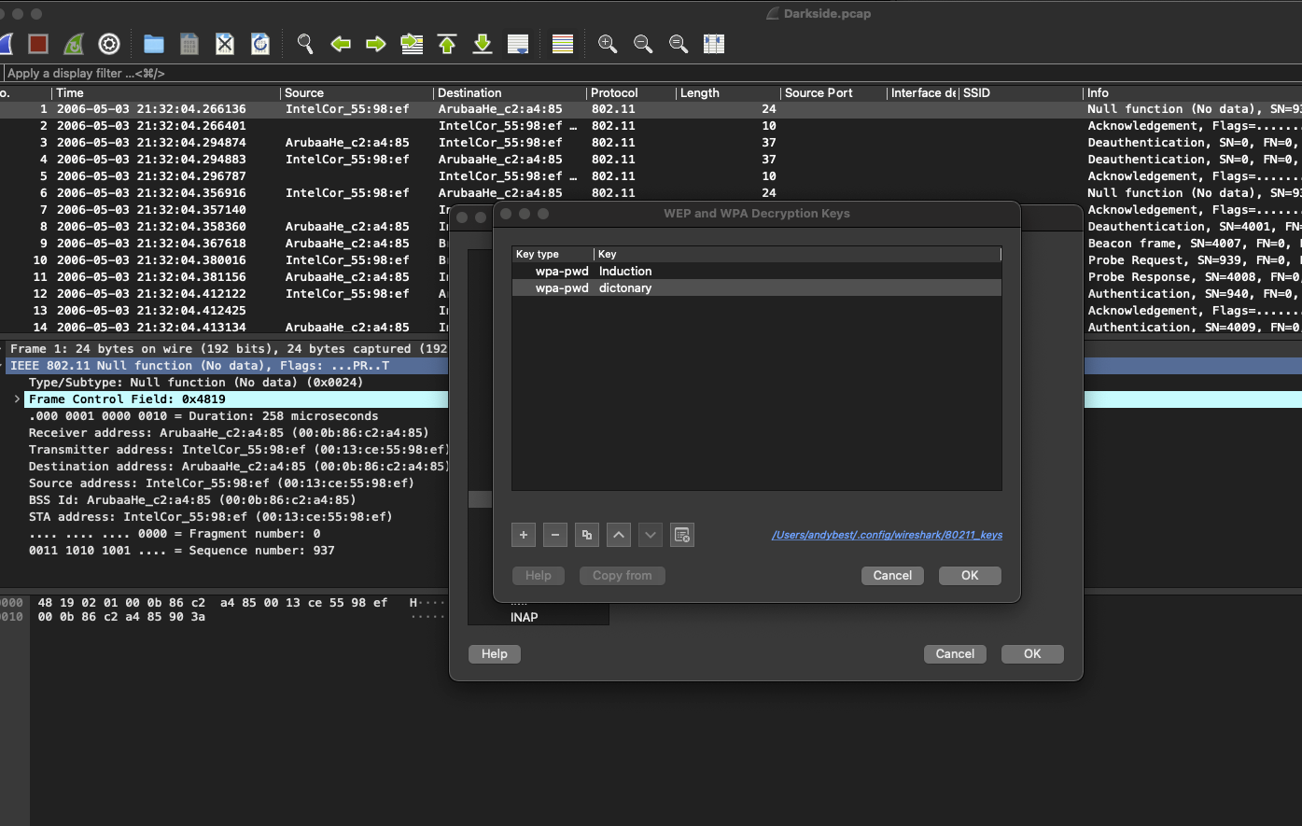

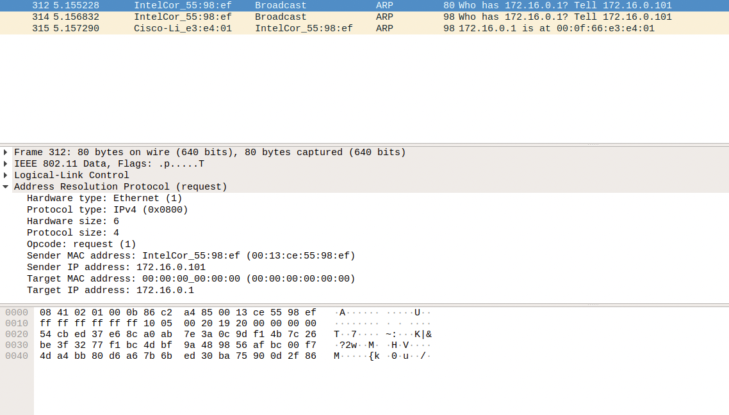

### **Mission 7**

As a thank you for saving the galaxy, the Resistance wants to send you a secret message!

Your Mission:

* View the DNS record from Mission #4.
* The Resistance provided you with a hidden message in the TXT record, with several steps to follow.
* Follow the steps from the TXT record.
  + **Note**: A backup option is provided in the TXT record (as a website) in case the main telnet site is unavailable
* Take a screen shot of the results.